P
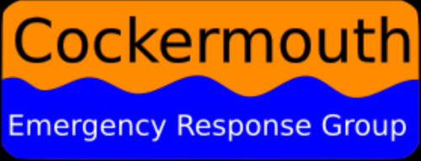
Contact us on chair@cerg.org.uk
Admin: jo.crozier17@gmail.com
Mobile: 07852 599794
Volunteer Confidentiality Agreement
Thank you for volunteering with Cockermouth Emergency Response Group. Whilst you are volunteering you may have access to information that needs to be kept confidential. This includes information about the people who have been flooded – particularly information about their personal circumstances such as their names, addresses, information about their financial position and details of the challenges they are facing following the emergency.
When someone gives us any confidential information, they need to be sure that we will not pass this to anyone that they have not given us permission to share it with. This means, for example, that you must not discuss these details with your friends and family, or post it on social media.
However, you may also hear information which causes you concern – for example, information which suggests that someone needs immediate help (for example, a child at risk, or an older person in need of urgent support). If this happens you should share this information with a member of the CERG board who co-ordinates the volunteer support, as soon as possible so that appropriate action can be taken BUT remember anyone can call Social Services or the Police when they are concerned about extreme situations.
Confidentiality Statement
I understand that whilst volunteering with Cockermouth Emergency Response Group that I may come across information that is confidential. I agree that I will never disclose such confidential information to anyone outside CERG.
Signed ………………………………………………….
Print Name …………………………………………….
Date …………………………………………………….

